**Java Web开发**

**实验一**

**作业报告**

|  |  |
| --- | --- |
| 学 院 | 计算机 |
| 所在系 班 级 | 2017软件工程系18班 |
| 学 号 姓 名 | 祝志豪 |
| 指 导 教 师 | 郭晓燕 |
| 完 成 时 间 | 2019年3月- |

# 实验题目

1. 熟悉MyEclipse环境，在软件下绑定JDK和Tomcat，新建项目并运行；（必做）

1. 在MyEclipse环境下新建一个项目取名为Webtest+学号（必做）

a)并在其下创建一个JSP程序，并在IE下运行；

b）将课件第一章的例题input.jsp、receive.jsp内容拷入项目中。并运行访问该JSP页面；

3．预习第二章，编写并运行第P29页例题HelloServelt.java文件。

# 分析与设计

根据题目要求，计划设计几个文件来完成实验，每个文件的名字、作用。如果是类，要求写出类的变量和方法

# 关键源码（部分）

第一题：

<%@ page language=*"java"* import=*"java.util.*"* pageEncoding=*"UTF-8"*%>

<%

String path = request.getContextPath();

String basePath = request.getScheme()+"://"+request.getServerName()+":"+request.getServerPort()+path+"/";

%>

<!DOCTYPE HTML PUBLIC "-//W3C//DTD HTML 4.01 Transitional//EN">

<html>

<head>

<base href=*"*<%=basePath%>*"*>

<title>My JSP 'index.jsp' starting page</title>

<meta http-equiv=*"pragma"* content=*"no-cache"*>

<meta http-equiv=*"cache-control"* content=*"no-cache"*>

<meta http-equiv=*"expires"* content=*"0"*>

<meta http-equiv=*"keywords"* content=*"keyword1,keyword2,keyword3"*>

<meta http-equiv=*"description"* content=*"This is my page"*>

<!--

<link rel="stylesheet" type="text/css" href="styles.css">

-->

</head>

<body>

This is my JSP page. <br>

</body>

</html>

第二题：

a)

<%@ page language=*"java"* import=*"java.util.*"* pageEncoding=*"UTF-8"*%>

<%

String path = request.getContextPath();

String basePath = request.getScheme()+"://"+request.getServerName()+":"+request.getServerPort()+path+"/";

%>

<!DOCTYPE HTML PUBLIC "-//W3C//DTD HTML 4.01 Transitional//EN">

<html>

<head>

<base href=*"*<%=basePath%>*"*>

<title>My JSP 'index.jsp' starting page</title>

<meta http-equiv=*"pragma"* content=*"no-cache"*>

<meta http-equiv=*"cache-control"* content=*"no-cache"*>

<meta http-equiv=*"expires"* content=*"0"*>

<meta http-equiv=*"keywords"* content=*"keyword1,keyword2,keyword3"*>

<meta http-equiv=*"description"* content=*"This is my page"*>

<!--

<link rel="stylesheet" type="text/css" href="styles.css">

-->

</head>

<body>

This is my JSP page. <br>

</body>

</html>

b)

<%@ page language=*"java"* import=*"java.util.*"* pageEncoding=*"UTF-8"*%>

<%

String path = request.getContextPath();

String basePath = request.getScheme()+"://"+request.getServerName()+":"+request.getServerPort()+path+"/";

%>

<!DOCTYPE HTML PUBLIC "-//W3C//DTD HTML 4.01 Transitional//EN">

<html>

<head>

<base href=*"*<%=basePath%>*"*>

<title>My JSP 'MyJsp.jsp' starting page</title>

<meta http-equiv=*"pragma"* content=*"no-cache"*>

<meta http-equiv=*"cache-control"* content=*"no-cache"*>

<meta http-equiv=*"expires"* content=*"0"*>

<meta http-equiv=*"keywords"* content=*"keyword1,keyword2,keyword3"*>

<meta http-equiv=*"description"* content=*"This is my page"*>

<!--

<link rel="stylesheet" type="text/css" href="styles.css">

-->

</head>

<body bgcolor=*cyan*>

<Font size=*8*>

<FORM action=*"receive.jsp"* method=*post* name=*form*>

请输入下列信息：<br>

输入你的姓名：<INPUT type=*"text"* name=*"name"* value=*"张三"*><br>

选择你的性别：<INPUT type=*"radio"* name=*"R"* value=*"男"* check=*"default"*>男

<INPUT type=*"radio"* name=*"R"* value=*"女"* check=*"default"*> 女<br>

选择你喜欢的歌手：

<input type=*"checkbox"* name=*"superstar"* value=*"李歌手"*>李歌手<br>

<input type=*"checkbox"* name=*"superstar"* value=*"吴歌手"*>吴歌手<br>

<input type=*"checkbox"* name=*"superstar"* value=*"周歌手"*>周歌手<br>

<input type=*"checkbox"* name=*"superstar"* value=*"刘歌手"*>刘歌手<br>

<input TYPE=*"hidden"* value=*"这是隐藏的信息"* name=*"secret"*>

<input TYPE=*"submit"* value=*"提交"* name=*"submit"*>

</FORM>

</Font>

</body>

</html>

<%@ page language=*"java"* import=*"java.util.*"* pageEncoding=*"UTF-8"*%>

<%

String path = request.getContextPath();

String basePath = request.getScheme()+"://"+request.getServerName()+":"+request.getServerPort()+path+"/";

%>

<!DOCTYPE HTML PUBLIC "-//W3C//DTD HTML 4.01 Transitional//EN">

<html>

<head>

<base href=*"*<%=basePath%>*"*>

<title>My JSP 'input.jsp' starting page</title>

<meta http-equiv=*"pragma"* content=*"no-cache"*>

<meta http-equiv=*"cache-control"* content=*"no-cache"*>

<meta http-equiv=*"expires"* content=*"0"*>

<meta http-equiv=*"keywords"* content=*"keyword1,keyword2,keyword3"*>

<meta http-equiv=*"description"* content=*"This is my page"*>

<!--

<link rel="stylesheet" type="text/css" href="styles.css">

-->

</head>

<body bgcolor=*cyan*>

<Font szie=*8*>

<a href=*"index.jsp"*>回到首页</a>

<% request.setCharacterEncoding("utf-8");

String yourName=request.getParameter("name");

String yourSex=request.getParameter("R");

String secretMess=request.getParameter("secret");

String personName[]=request.getParameterValues("superstar");

out.println("<p> 你的姓名："+yourName+"</p>");

out.println("<p> 你的性别："+yourSex+"</p>");

out.println("<p> 你喜欢的歌手：");

**if**(personName==**null**)

{

out.println("一个也不喜欢");

}

**else**

{

**for**(**int** k=0;k<personName.length;k++)

{

out.println(" "+personName[k]);

}

}

out.println("<p> hidden提交的值："+secretMess); %>

<p>姓名：${param.name }</p>

</FONT>

</body>

</html>

第三题：

**package** cc.openhome;

**import** java.io.IOException;

**import** java.io.PrintWriter;

**import** javax.servlet.ServletException;

**import** javax.servlet.annotation.WebServlet;

**import** javax.servlet.http.HttpServlet;

**import** javax.servlet.http.HttpServletRequest;

**import** javax.servlet.http.HttpServletResponse;

@WebServlet("/hello.view") //访问地址

**public** **class** HelloServlet **extends** HttpServlet {

@Override

**protected** **void** doGet(HttpServletRequest request,

HttpServletResponse response)**throws** ServletException,IOException{

response.setContentType("text/html;charset=UTF-8");

PrintWriter out=response.getWriter();

String name =request.getParameter("name");

out.println("<html>");

out.println("<head>");

out.println("<title>hello Servlet</title>");

out.println("</head>");

out.println("<body>");

out.println("<h1> Hello!" + name + " ! </h1>");

out.println("</body>");

out.println("</html>");

out.close();

}

}

# 运行效果图

第一题：

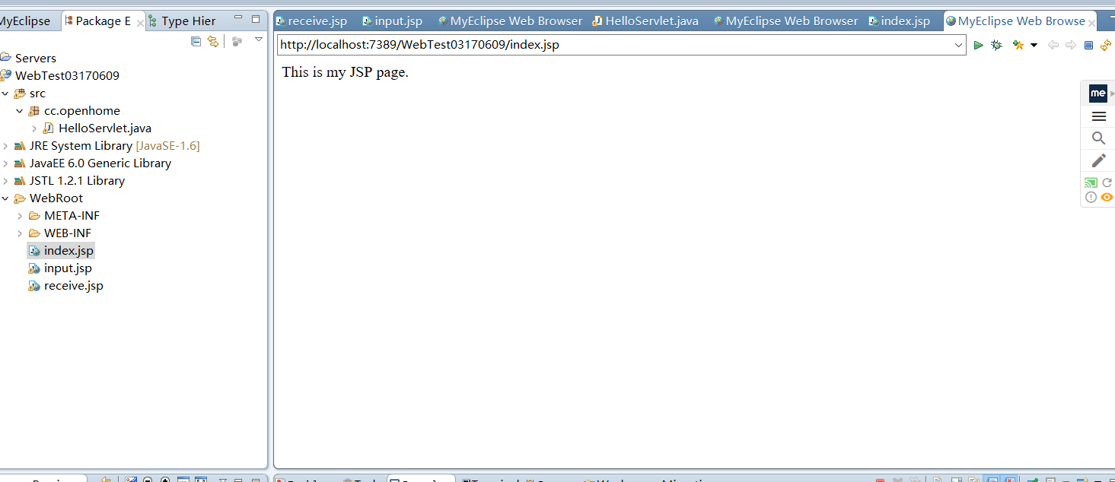

第二题：

a)

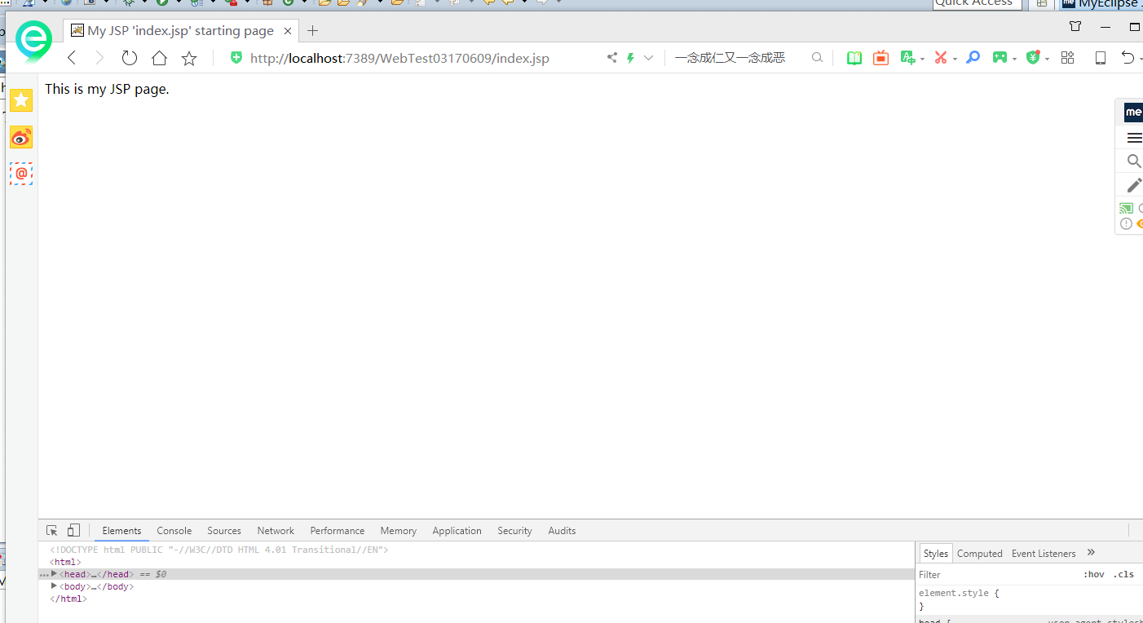

b)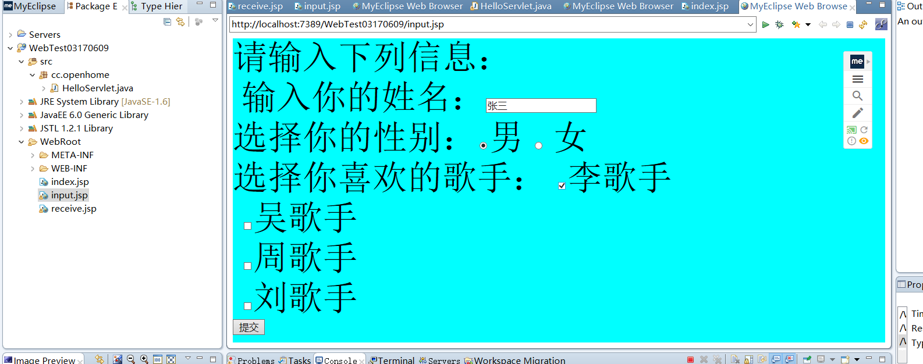

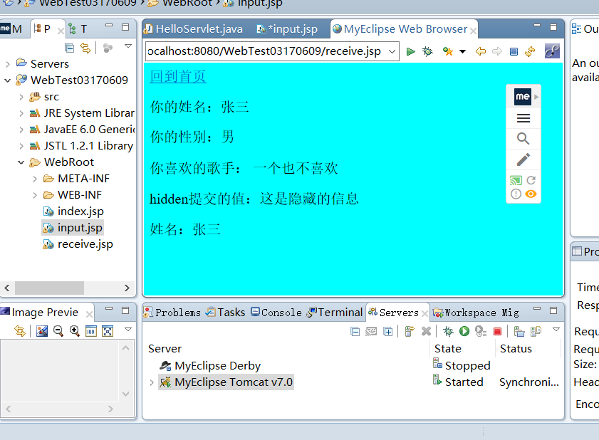

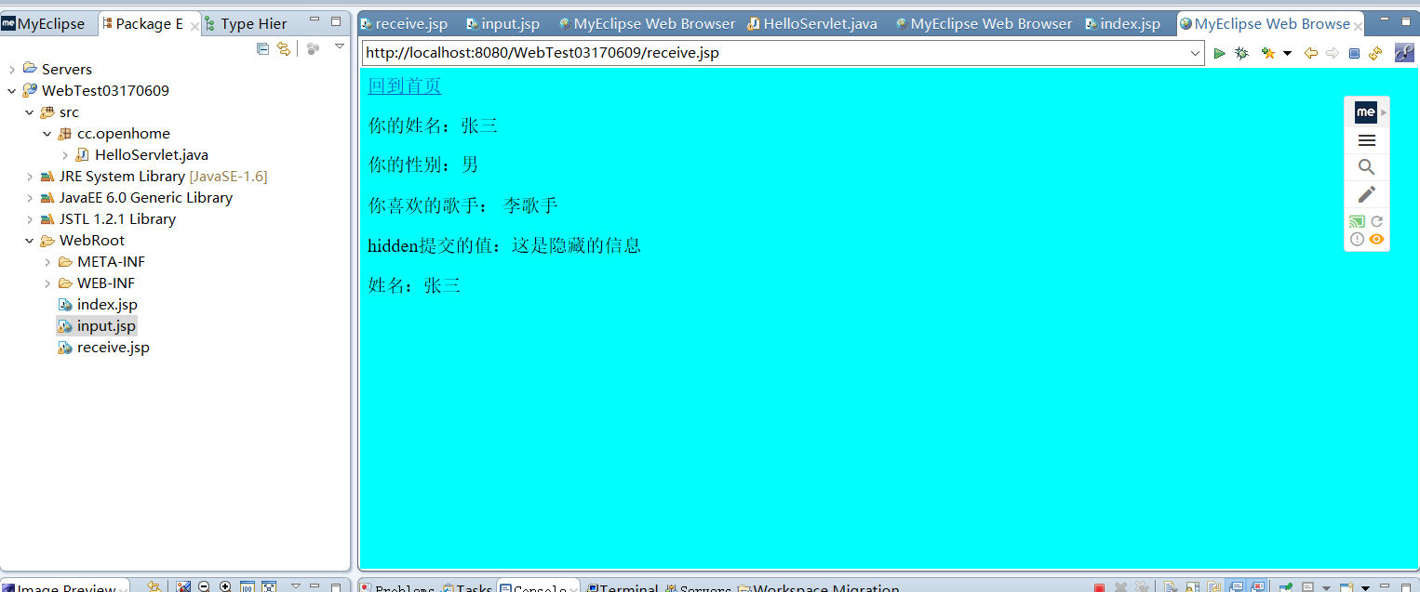

第三题

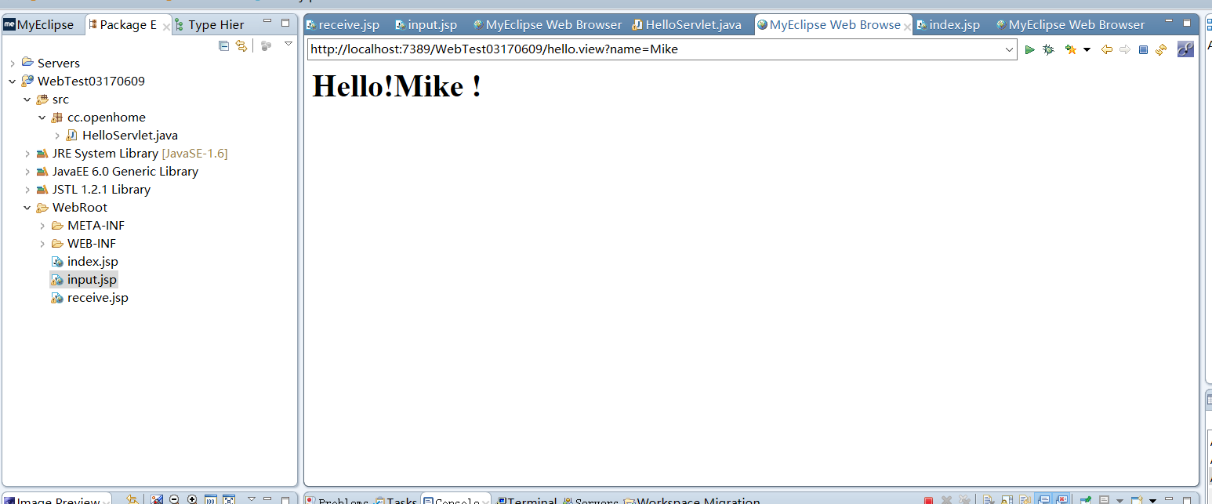

# 收获与问题

解决了端口冲突的问题和中文乱码的问题